Software Requirements Specification

for

Sale Opportunity

**SOP Systems**

Table of Contents

Table of Contents ii

Revision History ii

1. Introduction 1

1.1 Purpose 1

1.2 Document Conventions 1

1.3 Intended Audience and Reading Suggestions 1

1.4 Product Scope 1

1.5 References 1

2. Overall Description 2

2.1 Product Perspective 2

2.2 Product Functions 2

2.3 User Classes and Characteristics 2

2.4 Operating Environment 2

2.5 Design and Implementation Constraints 2

2.6 User Documentation 2

2.7 Assumptions and Dependencies 3

3. External Interface Requirements 3

3.1 User Interfaces 3

3.2 Hardware Interfaces 3

3.3 Software Interfaces 3

3.4 Communications Interfaces 3

4. System Features 4

5. Other Nonfunctional Requirements 4

5.1 Performance Requirements 4

5.2 Safety Requirements 5

5.3 Security Requirements 5

5.4 Software Quality Attributes 5

5.5 Business Rules 5

6. Other Requirements 5

Appendix A: Glossary 5

Appendix B: Analysis Models 5

Appendix C: To Be Determined List 6

Revision History

|  |  |  |  |
| --- | --- | --- | --- |
| **Name** | **Date** | **Reason For Changes** | **Version** |
|  |  |  |  |
|  |  |  |  |

# Introduction

## Purpose

The purpose of this document is to provide a detailed overview of our software product and to describe the project requirements that we provided with by the client in order to ensure that the software we produce will be consistent with need of our client.

## Document Conventions

This document is divided into serval section which are listed numerically, each section starting with headline with a big bold font following with subsection with smaller bold font.

## Intended Audience and Reading Suggestions

The intended audience of this document consists of clients, travel agents, development team, QA team, managers and the project supervisor, before reading this document it is highly recommended to read the Vision Document to get an overview of the product.

## Product Scope

The software will facilitate the user interaction with data base by providing an adjusted management system to the data of the company,the travel agents will have efficient and organized way to manage packages and track orders. the clients will have an easy and wide functionality user experience including contacting travel agents, search packages and flights and manage their orders, and the manger will the have all the agent options and in addition access to the agents accounts and the ability of add/remove agents accounts.

## References



SRS template.

# Overall Description

## Product Perspective

In the past a client was must to approach the agency in order to book his vacation and this often requires a lot of time and effort without the ability to easily track and cancel orders. with our product the users are provided with a friendly user-interface through which they can interact with the system, the software helps clients and agents to list searched results, process booking, modification and cancellation to existing reservations,….manager

## Product Functions

**2.2.1 Login**

Function that receives username and password to identify the user. Then the user is sent to the right menu.

### 2.2.2Manger access menu

A menu customized featuring the manager's abilities.

### 2.2.3Agent menu

A menu to the agent that is customized according to his abilities.

### 2.2.4 Client menu

A menu to the client that is customized according to his abilities.

**2.2.5 Add package**

The travel agent will have the ability to add a package to the data base.

### 2.2.6 Delete package

The travel agent will have the ability to remove a package from the data base.

### 2.2.7 Edit package

The travel agent will have the ability to edit a package's details.

**2.2.8 Edit quantity of packages**The agent will be able to edit the quantity of the products.

**2.2.9 Track orders**

User will be able to see purchase date, package date and order status

### 2.2.9.1 Client

Clients can track their orders only

**2.2.9.2 Agent**

Agents can track their client's orders

**2.2.10 Sort orders**

Have the ability to sort viewed orders by the following criterias:

**2.2.10.1 Order date**

Sort orders by the date of the order.  
**2.2.10.2 Package date**

Sort by the package date.  
**2.2.10.3 Order status**The user will be able to look from specific status orders – processing, approved, cancelled.

### 2.2.11 Search by category

### Ability to search and view packages by the following categories:

**2.2.11.1 Date range**Package date  
**2.2.11.2** **Departure date**Departure date of flight

### 2.2.11.3 Destination by destination of the package 2.2.11.4 Price range by price ranges – from lowest or from highest

**2.2.12 Order status**

Ability to change status of order

### 2.2.12.1 Agent

### The travel agent will have the ability to approve a processing order or cancel it.

### 2.2.12.2 Client

### The client will have the ability to cancel an order.

### 2.2.13 Contact

### The user can leave a message with his details to the agents list of requests to contact him

### 2.2.14 Leave a feedback Client user can leave a free text feedback and rate a used package

**2.2.15 My orders**After the client bought a package it will be added to his orders list.

**2.2.16 Popular packages**After a package was bought x time it will be added to a list of popular packages and will be sorted by client's rating.

**2.2.17 Create discount**The manger can create a new discount code.

**2.2.18 Use discount**In the order process the user can put a coupon code and the price will be cut respectively.

**2.2.19 Box message**After the manager sends a message it will be added to the list messages of the agents/clients

**2.2.20 Send message by manager**The manger will have the ability to add message to the clients/agents messages list.

**2.2.21 is valid**Overloading function that checks validity of date, code etc

**2.3 User Classes and Characteristics**

There will be two kinds of user's classes agent and client. The agent will have access to all the software features. client will have a more limited number of features. The additional features of the agent are packages management.

## Operating Environment

The system runs on Microsoft Windows 7/8/10 versions 86x and 64 bits.

## Design and Implementation Constraints The company must have a large enough storage higher priority to cloud

## User Documentation

The user will receive a manual detailing the functionality of the software.

the client can contact our service department via mail

## Assumptions and Dependencies

Our assumption that employee Database will be received from the HR department in ‘.txt’ file which the program will assign 'LOG IN' details of all company agents.

The file will be as follows: First name, Last name, Password, Role. (all on different lines) employees separated by '$' sign

The database includes details of access for each user such as Employee & Manager stated by Role.

The system assumes that when payment details are valid, the transaction approved.

# External Interface Requirements

## User Interfaces

The software will have basic menu bar with options, one for agents, one for managers and one for the clients.

See the prototype presentation (style may differ from the final product).

## Hardware Interfaces

The application requires a monitor and working computer with OS installed

## Software Interfaces

The application will have access to data base that was written by a third-party software program (in a .txt format).

The interface is as shown in the prototype.

## Communications Interfaces

Communication with human resources databases to transfer data into the software.

# System Features

## 4.1 Reserve package

**4.1.1 Description and Priority**The top priority feature will allow to the client to book a vacation according to his will,  
by choosing out of the agency packages list which includes flights, hotels and vacations.

**4.1.2 Stimulus/Response Sequences**  
The client will choses a package out of the list by clicking “book it”. Then a registered/login window will pop up in case the user yet to be logged in. After that, the user will be moved to the summary page and finally to the payment page.

**4.1.3 Functional Requirements**REQ-1: User must be logged in, otherwise the access to the reservation will not be available

REQ-2: The availability of the package needs to be updated all the time.

REQ-3: The company must have a connection to payment system.

## 4.2 Packages Database modification

**4.2.1 Description and Priority**The agents will be able to modify the list of the packages the travel agency offers by adding, editing and deleting packages from the database. In order to keep the database updated always.

**4.2.2 Stimulus/Response Sequences**  
After the system recognized the agent/manager the user will choose the “view packages” option. Then he will have to click on the edit or add/remove. From there he will have access to the database.

**4.2.3 Functional Requirements**REQ-1: Only agent/manager type of user will have the access to this feature

REQ-2: The package edit/add must be time valid and according to given format ***

## 4.3 Login

**4.3.1 Description and Priority**Every user will have an username and password in the DB and the system will automatically identify the type of the user and will send him a suitable menu. Only registered users will have access to interaction and personal features such as making/viewing orders.

**4.3.2 Stimulus/Response Sequence**  
From the home page the user can click the login feature and then will type his username and password. The system will recognize the type of the user and will send him to the right menu.

**4.3.3 Functional Requirements**REQ-1: Username and password must be existing in the DB.

REQ-2: User will have to type the password correctly – password is case sensitive

## 4.4 Categorized search

**4.4.1 Description and Priority**The user will have the option to search for a package according to the following categories: destination, price range, dates or a combination of all.

**4.4.2 Stimulus/Response Sequences**  
After the user clicks “search packages” they will have to fill their demands.

**4.4.3 Functional Requirements**REQ-1: Valid date - otherwise the user will have to fill the date again.

REQ-2: Non - negative price range – otherwise the user will have to fill it again

## 4.5 Track orders

**4.5.1 Description and Priority**The user will have the ability to view orders made and its details including: status, order date and package date. That way the user can see the order's details at any time.

**4.5.2 Stimulus/Response Sequences**  
Agent/manager will have to click on “view clients” choose a client than click on “track orders”. The client will have “my orders” option in his menu there he can see his orders and their status.

**4.5.3 Functional Requirements**REQ-1: There must be existing orders

REQ-2: Client can view only his orders, only agent can view all clients order.

**4.6 Order status**

**4.6.1 Description and Priority**

The user will be able to change order status. The agent will be able to approve processing orders or cancel them while the client will only be able to cancel in case anything irregular happens.

**4.6.2 Stimulus/Response Sequences**

The user will use the tracking orders feature to find the order he wishes to change status for. There he will be able to do so.

**4.5.3 Functional Requirements**

REQ-1: The order must exist in order to change its status.

REQ-2: You have to be an agent to approve a processing order.

## 4.7 Leave a message

**4.7.1 Description and Priority**The user will have the ability to leave a message in order to contact an agent for asking questions and make requests. The user's details will be noted in the message.

**4.7.2 Stimulus/Response Sequences**  
After the client logged in and got to the menu he will have to click “contact us” and then leave his message.

**4.7.3 Functional Requirements**REQ-1: Client must be logged in

## 4.8 Leave a feedback

**4.8.1 Description and Priority**After package been used the user will have the ability to rate the package (0-5) stars, when 5 is the highest score meaning the client enjoyed. The user will be able to write a short comment explaining their rating choice. This feature will assist other clients track the best packages.

**4.8.2 Stimulus/Response Sequences**  
After client get logged, he will choose the “my orders” option and choose a used package. Then he will have the option to leave his feedback.

**4.8.3 Functional Requirements**REQ-1: Client have to be logged in.  
REQ-2: Client will have to leave a message.  
REQ-3: Client will have to choose a used package

## 4.9 Popular packages and feedbacks

**4.9.1 Description and Priority**Before choosing a package the user will have the ability to view most popular packages sorted by feedbacks and view other client’s comments and suggestions.

**4.9.2 Stimulus/Response Sequences**  
After choosing the “view packages” option the user will have to choose “show me poplar packages” and after choosing a packages he can click on show me reviews.

**4.9.3 Functional Requirements**REQ-1: “popular” packages have to exist.

## 4.10 Discount offers

**4.10.1 Description and Priority**The system will give the manger the ability to send a message with the discount code to the clients list from the DB, and then the client will be able to activate the discount at the order.

**4.10.2 Stimulus/Response Sequences**  
A user will receive a message from the system with the discount code and then at ordering processes he will be able to activate it.

**4.10.3 Functional Requirements**REQ-1: Client code must be valid and not expired and case sensitive

REQ-2: The manger will have fill the discount details properly

## 4.11 Manager access

**4.11.1 Description and Priority**For highly operations of the system there will be a unique user who can modify the agents list, and discounts offers. Manager can do anything agent can do.

**4.11.2 Stimulus/Response Sequences**  
When manager logged in the system will recognize him automatically and send him the right menu

**4.11.3 Functional Requirements**REQ-1: Manager account has to exist

REQ-2: Details must be valid

## 4.12 Messages Box

**4.12.1 Description and Priority**The agents and the clients will have a messages box; the agents will receive a general notification from the agency management and the clients will get notification about discount offers.

**4.12.2 Stimulus/Response Sequences**  
After the user get logged in he will get notify for any new messages and by clicking on it he will be able to view the messages window.

**4.12.3 Functional Requirements**REQ-1: The user must be logged in.

REQ-2: Only the manager will be able to send messages.

# Other Nonfunctional Requirements

## Performance Requirements

The system must be linked with internal big enough storage in order to save the data base files,  
and also must to be linked with clearing system in order to make the payments  
time of running depend on the client ram and may differ from pc to pc

## Safety Requirements we recommend the company to back up their files in case loss of access to their company pcs , in case the system will crash by External disturbances all company closed transition will be saved and any in process operation will be delete.

## Security Requirements

The main security feature to secure the system from outside users is the user name and the password any user get which they may not be transfer, system files we be locked, files will be encrypted to avoid personal info leaked.

## Software Quality Attributes

* The product will be available to every agent of the travel agency company.
* The product is easy to use.
* The software is compact.
* The software is reliable and has updated bug fixes.

## Business Rules

* Only a travel agent can change the prices and accesses to all the available packages.
* The client has no ability to access other customer's details and will only be able to see his details and orders.

# Other Requirements

## Appendix A: Glossary

* SRS – Software Requirements Specification
* OS – Operating System
* HR – Human Resources
* RAM – Random Access Memory
* TBD – To Be Defined

**להוסיף את הדירוג של הפיצרים**

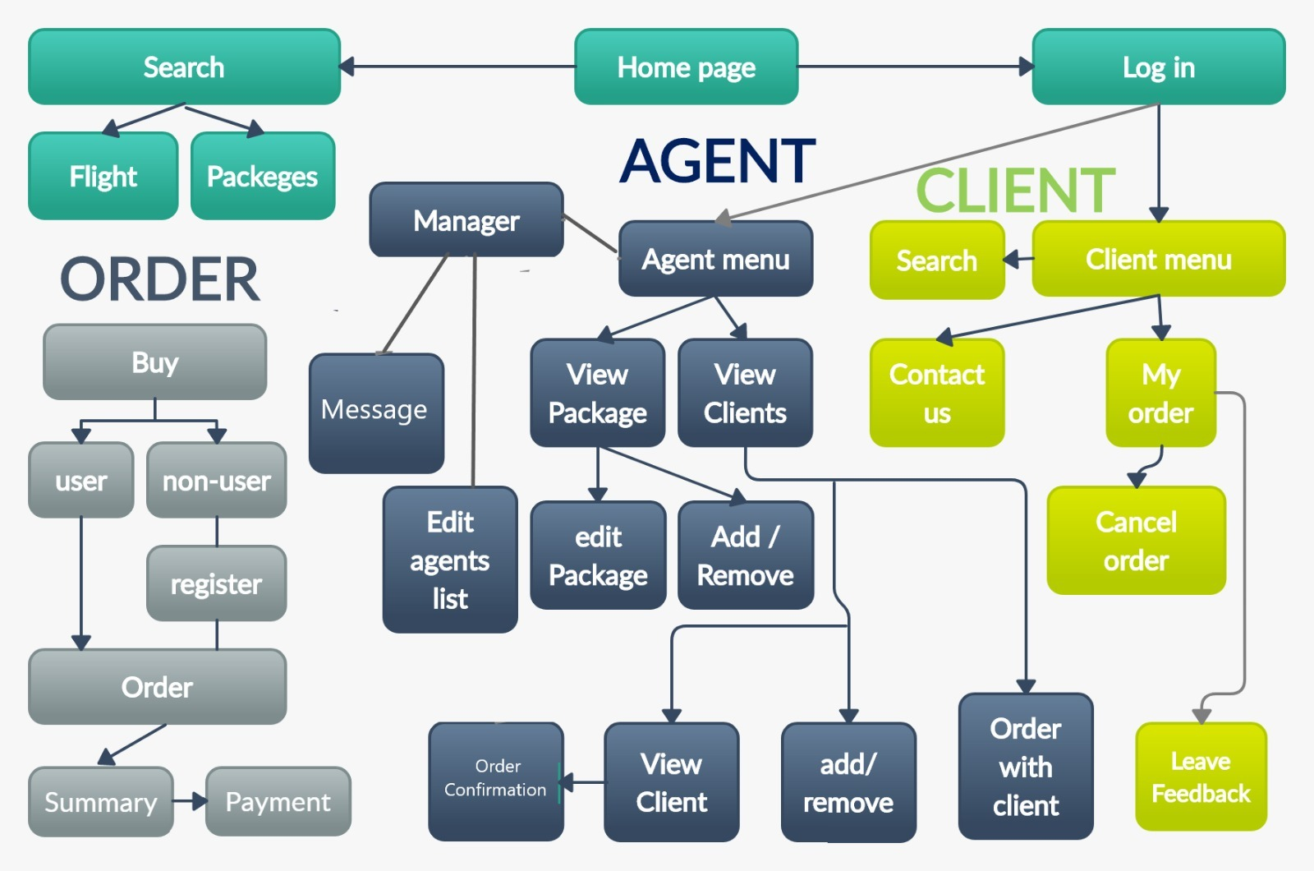**Appendix B: Analysis Models**

**Appendix C: To Be Determined List**

* Problems with server overload.
* Rating system on packages.